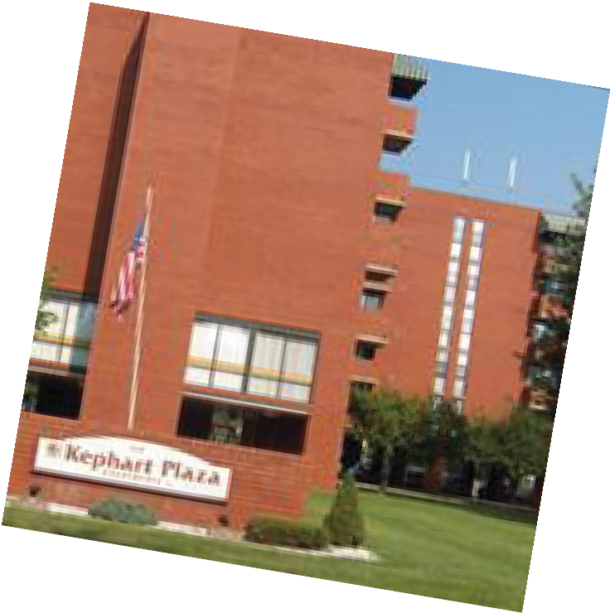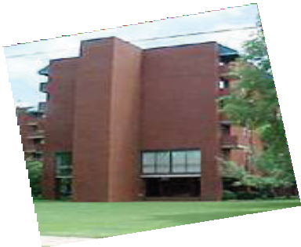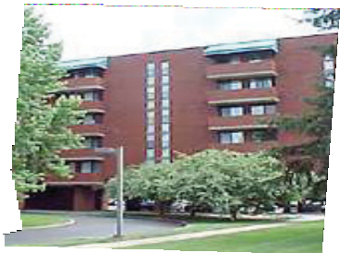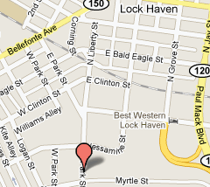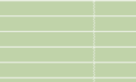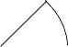KEPHART PLAZA
A Senior Community

Now Accepting Applications
1 Bedroom Apartments
No application fee. Beautiful park-like setting. 24-hour emergency maintenance.

Section 8 housing. Income restrictions apply
Qualifications: Credit check, no felonies, convictions or evictions. Verifiable rental history. Valid photo ID required for all applicants. Affordable housing for adults 62+ and/or handicapped or disabled.

BALCONY

- Resident Services Coordinator
- Community room
- On-site laundry
- Balcony
- Equipped kitchens

- Picnic area
- Pet friendly with deposit
- Utilities included in rent
- Wall A/C units
- Cable and Internet ready

BEDROOM 10 X 13

LIVING ROOM
11 X 13

Leasing Center Hours:
Mon-Fri 8am-12pm & 1pm-5pm
Office Number: 570-748-7775
TTY Number: 711
360 East Park Street, Lock Haven, PA 17745
www.oahskephart.com

BATH

KITCHEN

1 Bedroom: 462 sq ft

This property does not discriminate against persons with disabilities. The Section 504 Coordinator for this property can be reached by phone at (267) 516-0109; by TDD at 711 or by mail at P.O. Box 1524, Englewood Cliffs, NJ 07632, Attn: HUD Regional Manager.

